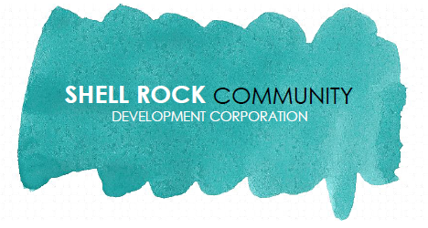

Thank you for considering a gift to the Shell Rock Community Development Corporation. We are a 501c3 nonprofit and donations are tax deductible. Please contact Levi at 319-885-4327 if you are interested in a sponsorship opportunity!

**FEATURED SPONSORSHIPS**

**HELP WANTED SPONSOR - $1,000**

An ad on our jobs/volunteer help wanted page of the website. Your business logo and a link to your website will appear on the page.

**E-NEWSLETTER SPONSOR - $750**

An ad in our monthly e-newsletter. Your business logo and a link to your website will appear on every newsletter sent out in 2021.

**COMMUNITY CALENDAR SPONSOR $1,000**

An ad on our community calendar page of the website. Your business logo and a link to your website will appear on the page.

**OTHER OPPORTUNITIES**

**GOLD SPONSOR $500**

Your business logo and a link to your website on our web page.

**SILVER SPONSOR $100-$500**

Your logo on our web page

**BRONZE SPONSOR $1-$99**

No online recognition